MongoDB Compass: 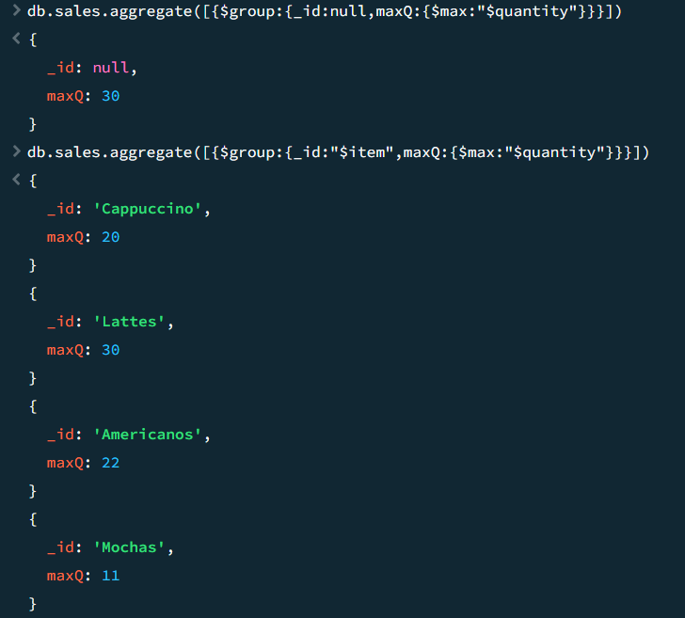 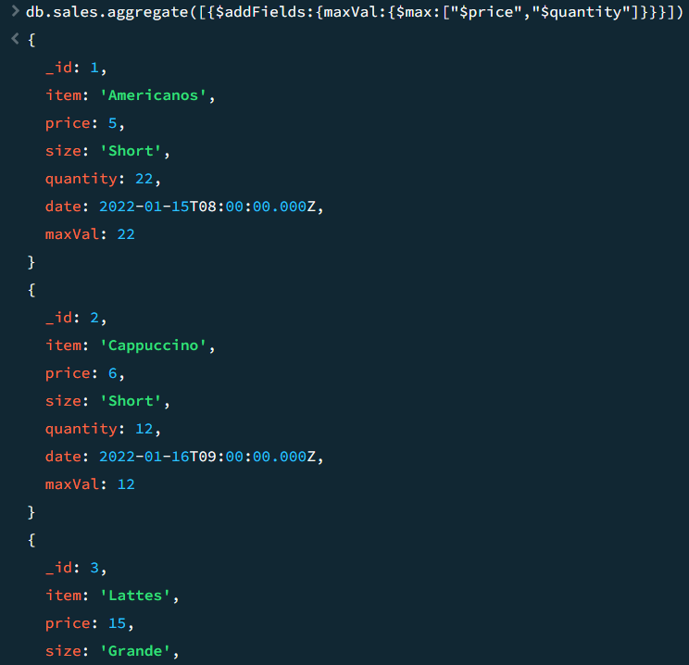
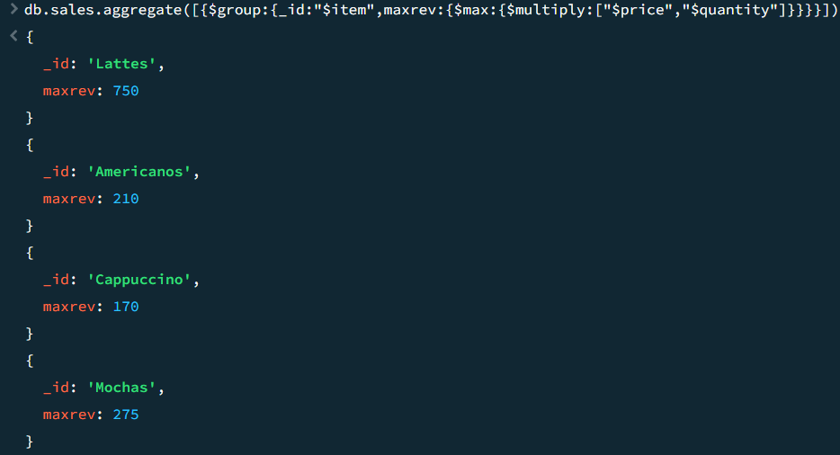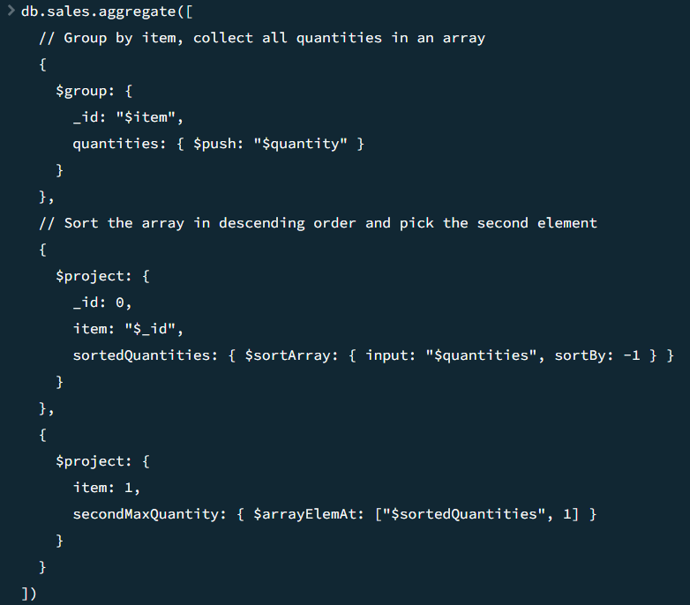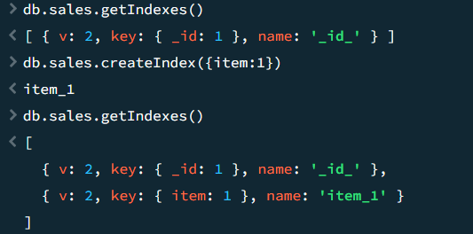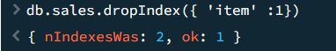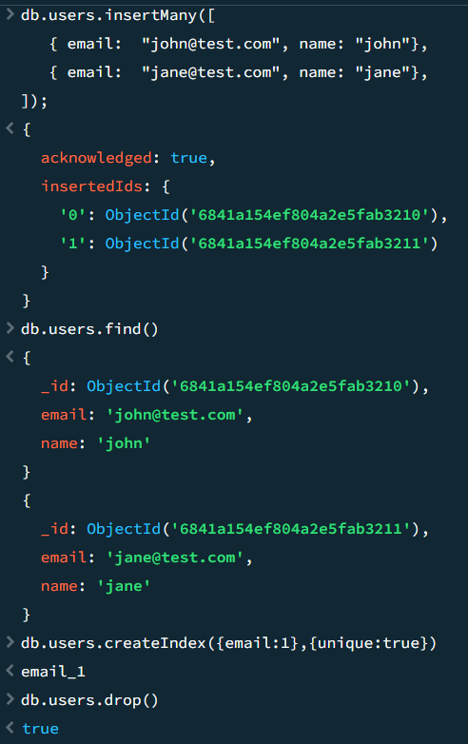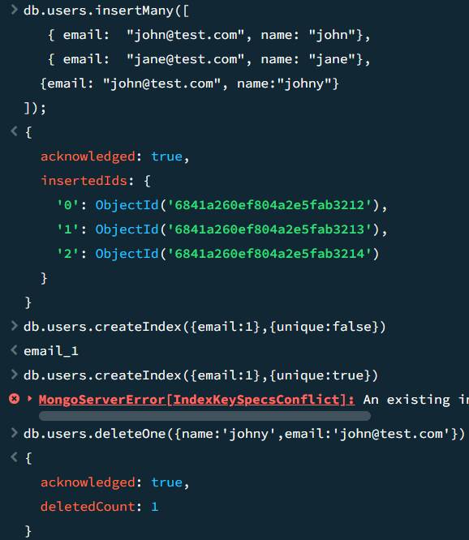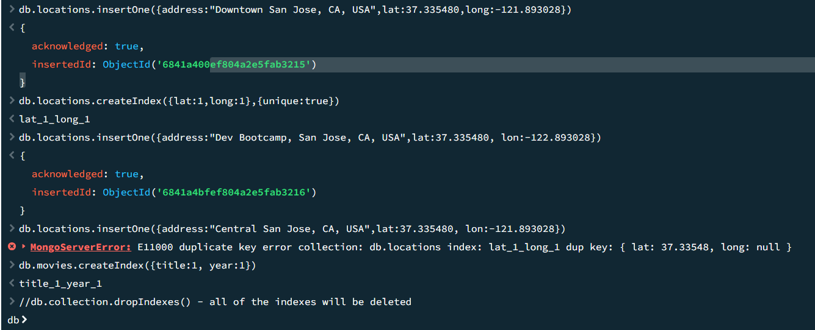
Eclipse:
MongoDB_Connection/src/connection/MongoDB.java

package connection;
import com.mongodb.MongoClient;
import com.mongodb.MongoCredential;
import com.mongodb.client.MongoDatabase;

public class MongoDB {
public static void main(String[] args) {
try {
MongoClient db
= new MongoClient("localhost", 27017);
MongoCredential credential;
credential
= MongoCredential
.createCredential(
"GFGUser", "mongoDb",
"password".toCharArray());
System.out.println(
"Successfully Connected"
+ " to the database");
MongoDatabase database
= db.getDatabase("mongoDb");
System.out.println("Credentials are: "
+ credential); }
catch (Exception e) {
System.out.println(
"Connection establishment failed");
System.out.println(e);
}}}
